**Assignment: ATmega328P Indicator Module Simulation in Proteus 8**

**1. Introduction**

This assignment focuses on designing and simulating an **Indicator Module** using an **ATmega328P** microcontroller. The system controls left and right indicator LEDs based on button inputs, simulates hazard lights, and manages a brake LED. The project is implemented using **Arduino IDE** and simulated in **Proteus 8**.

**2. Circuit Design**

**2.1 Components Used:**

* **Microcontroller**: ATmega328P
* **LEDs**: Left Indicator (PC0), Right Indicator (PC1), Brake LED (PB0)
* **Push Buttons**: Left Button (PC2), Right Button (PC4)
* **Power Supply**: 5V DC

**2.2 Circuit Diagram (Proteus 8)**

The simulation is designed using **Proteus 8**, where components are connected as follows:

| **Component** | **ATmega328P Pin** |
| --- | --- |
| Left LED | PC0 (A0 on Arduino) |
| Right LED | PC1 (A1 on Arduino) |
| Brake LED | PB0 (D8 on Arduino) |
| Left Button | PC2 (A2 on Arduino) |
| Right Button | PC4 (A4 on Arduino) |

**3. Software Implementation**

**3.1 Avr Code**

The system is programmed using **Arduino IDE and VS code** with direct register access. The logic includes:

* **LED control** based on button presses
* **Brake LED activation** when indicators are active
* **Debouncing mechanism** to prevent multiple triggers

**4. Proteus 8 Simulation Setup**

1. **Create a new project** in Proteus and add the ATmega328P microcontroller.
2. **Connect the LEDs and push buttons** according to the circuit diagram.
3. **Load the HEX file** (generated from Arduino IDE) into the ATmega328P in Proteus.
4. **Run the simulation** and observe LED behavior based on button presses.

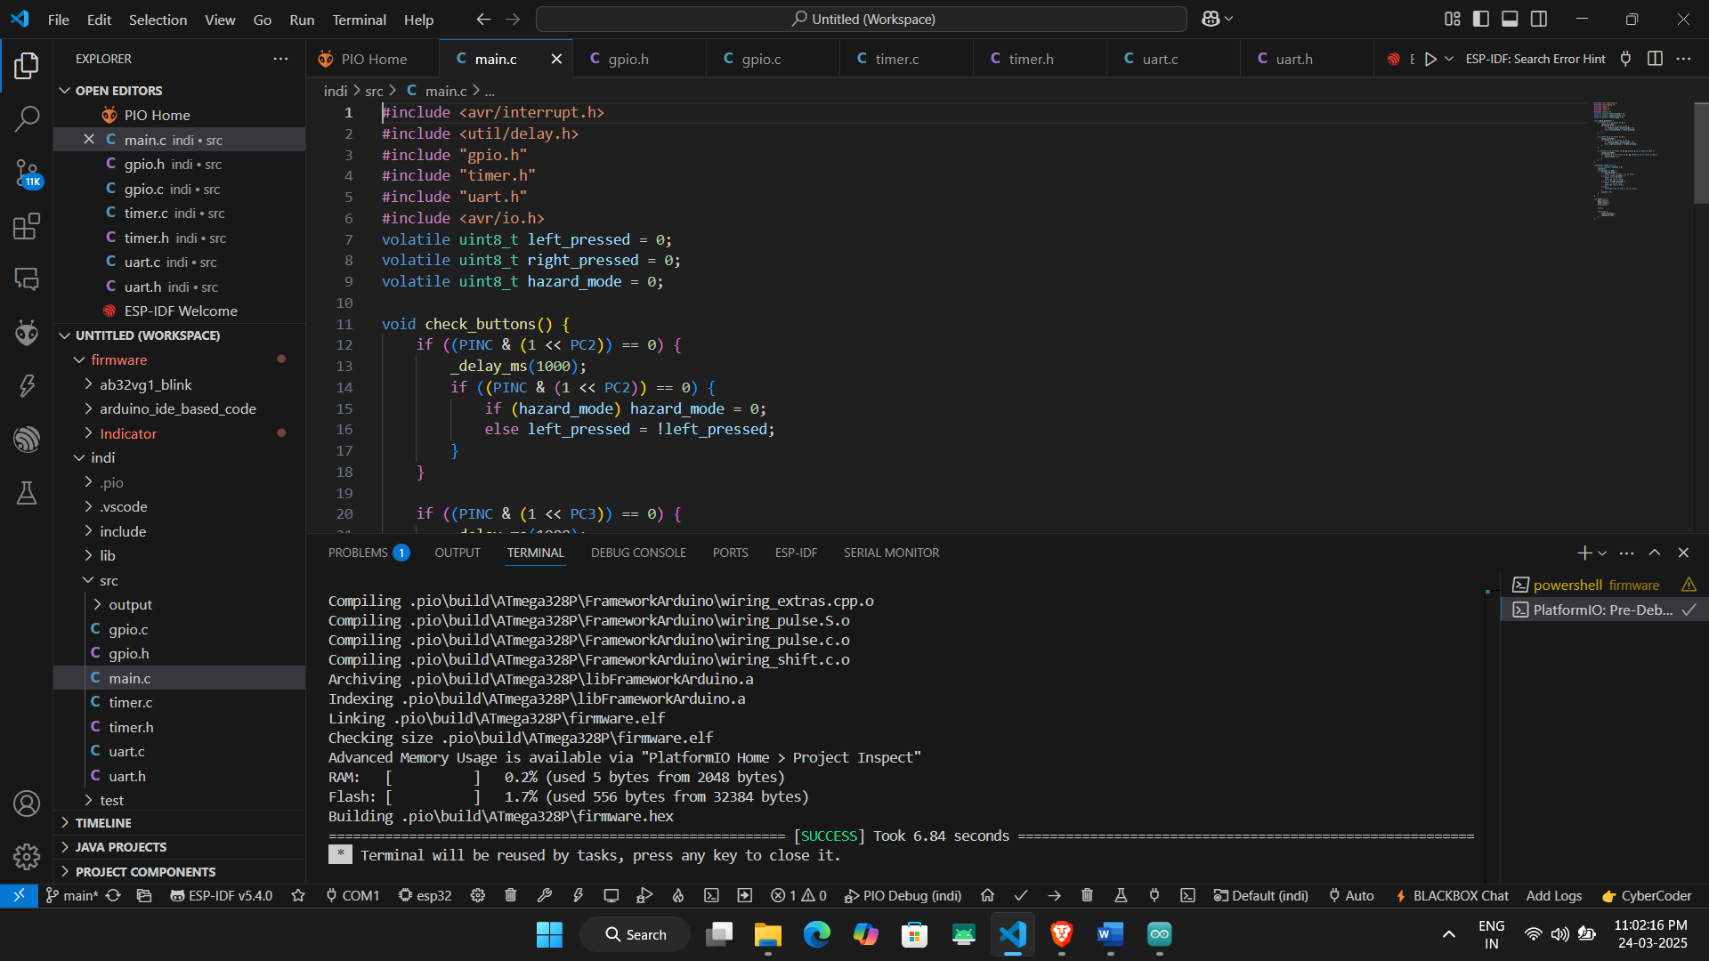**Figure 1: compiled code on vs code (Platformio)**

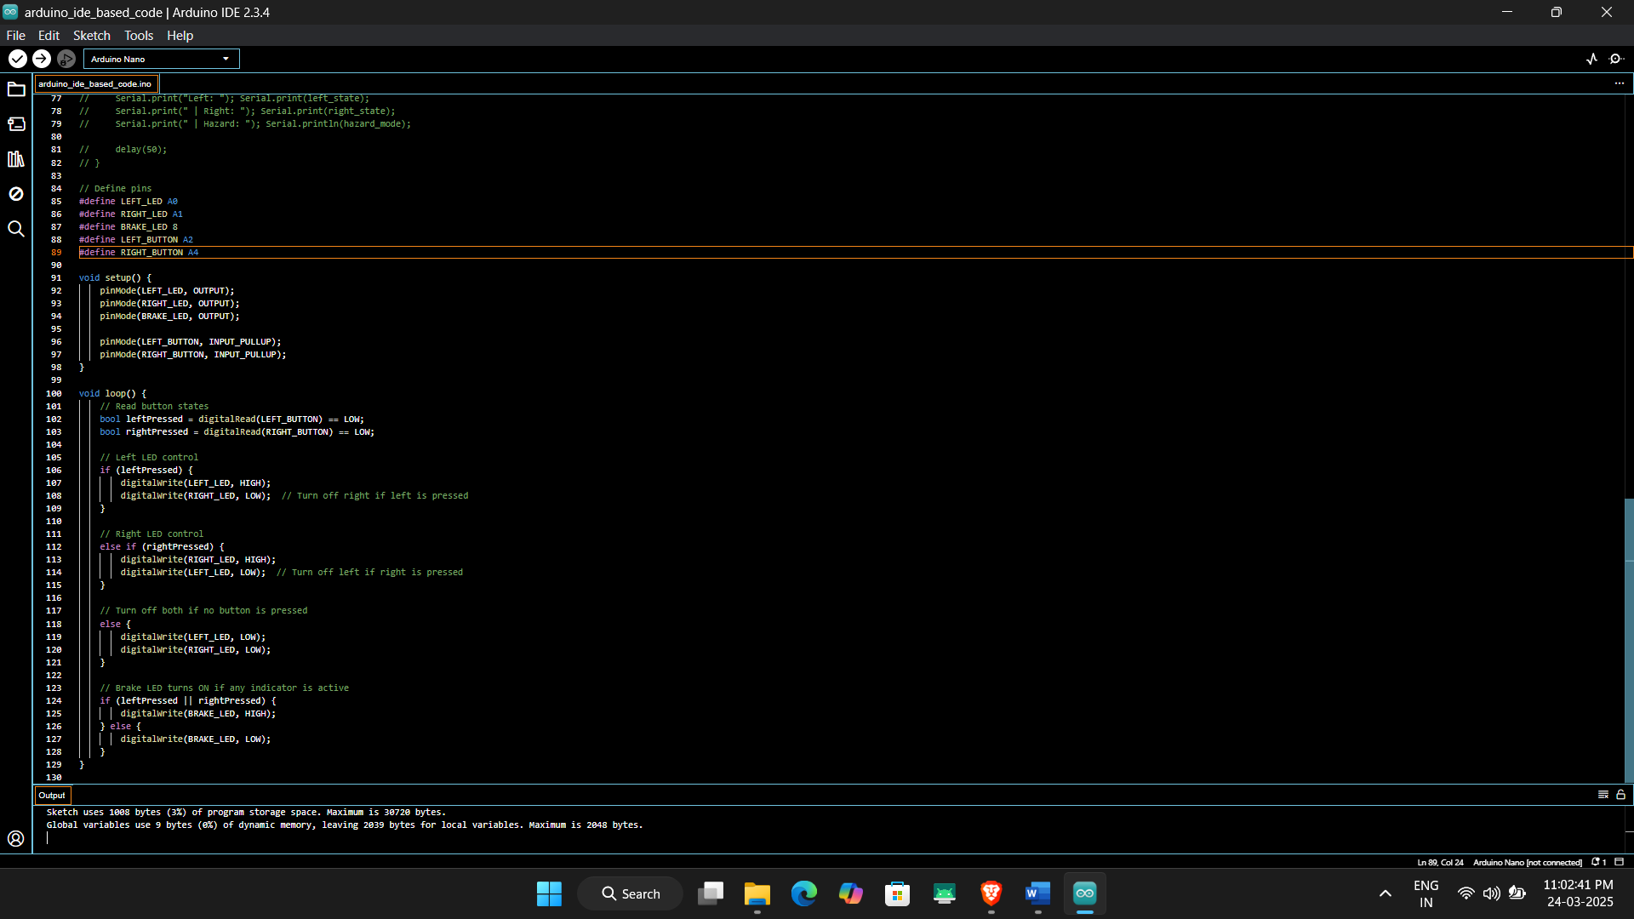**Figure 2: Compiled code on Arduino ide.**

**5. Expected Output**

| **Button Press** | **Action** |
| --- | --- |
| Left Button Pressed | Left LED ON, Right LED OFF |
| Right Button Pressed | Right LED ON, Left LED OFF |
| No Button Pressed | Both LEDs OFF |
| Any Indicator ON | Brake LED ON |

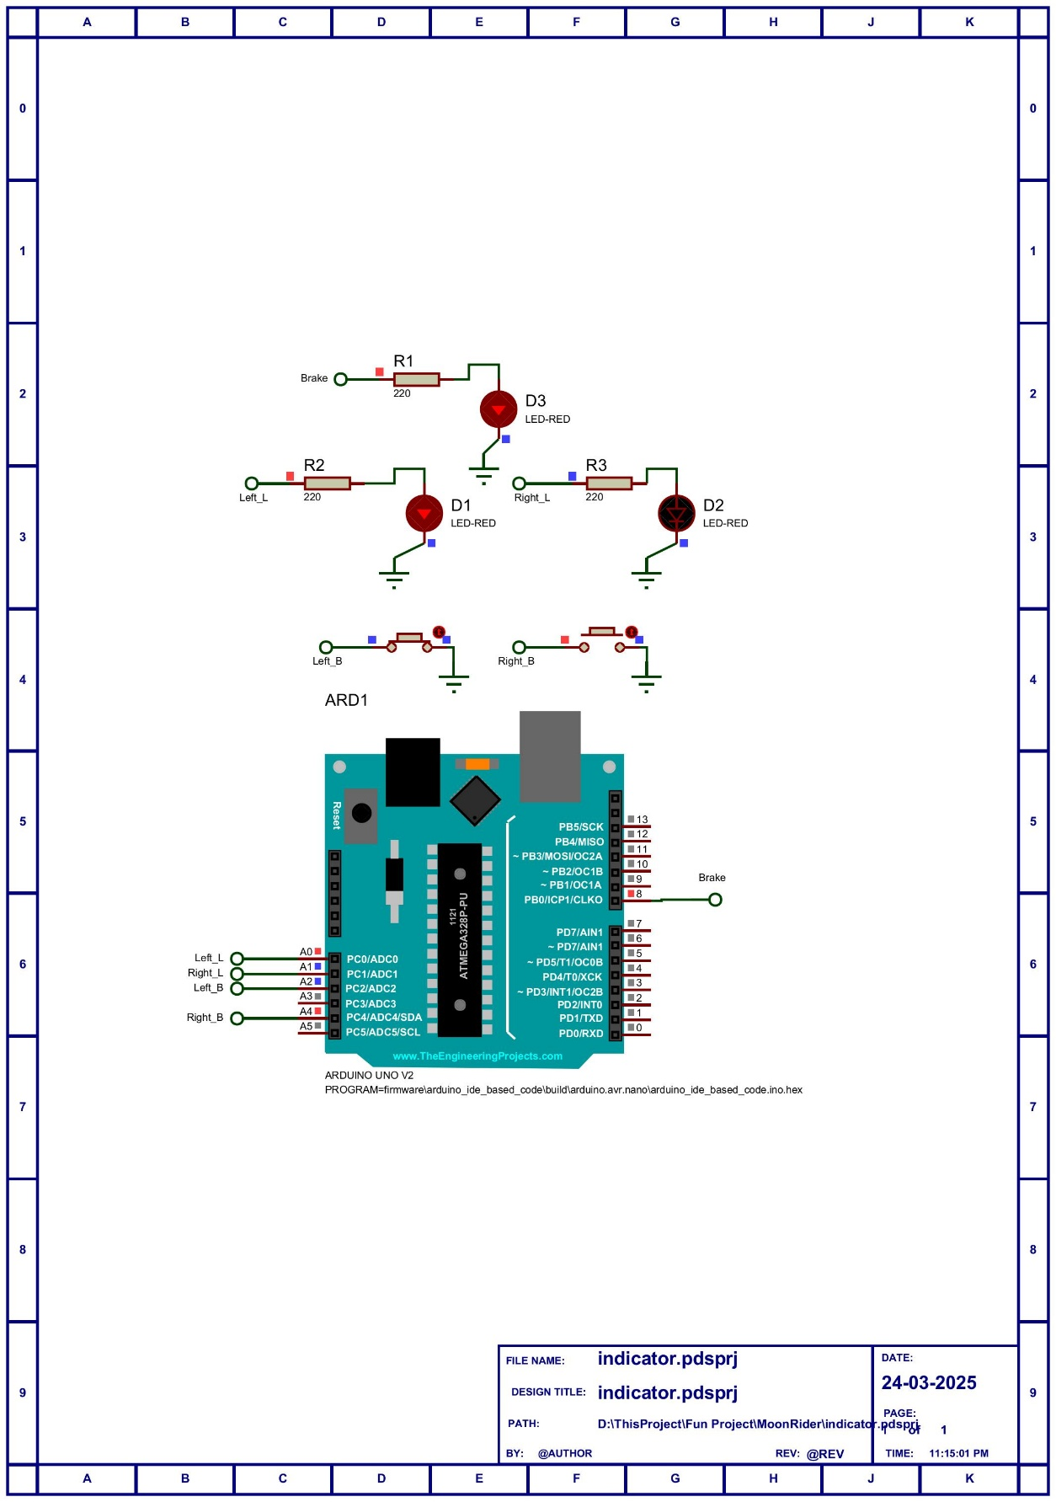

**Figure 3: left indicator**

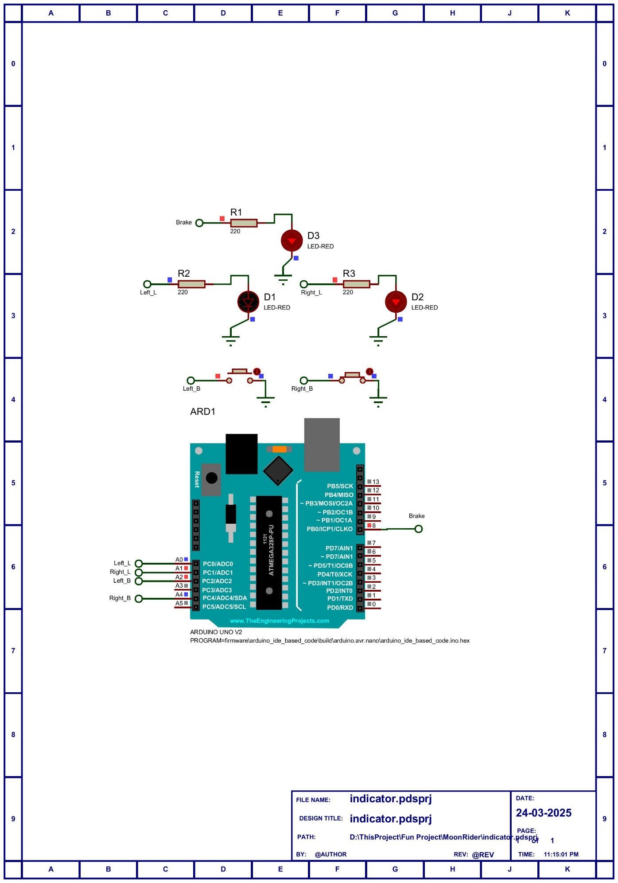

**Figure 4: Right indicator**

**6. Conclusion**

This project successfully simulates an **automobile indicator system** using ATmega328P. The Proteus 8 simulation confirms that the system responds correctly to button inputs, controlling the LEDs as expected. Further enhancements could include **hazard light blinking** and **UART logging** for real-world applications for UART logging, I have made custom serial monitor please check out github repository,

<https://github.com/AjayGautam1199/Custom-Serial-Monitor-for-Arduino-and-other-microcontroller>